[E124] Heat exchanger

Pull off the indicated hose clumps and silicone tubes from the fittings.

Unscrew the indicated screws and remove the valve from the original position in order to easier assembly.

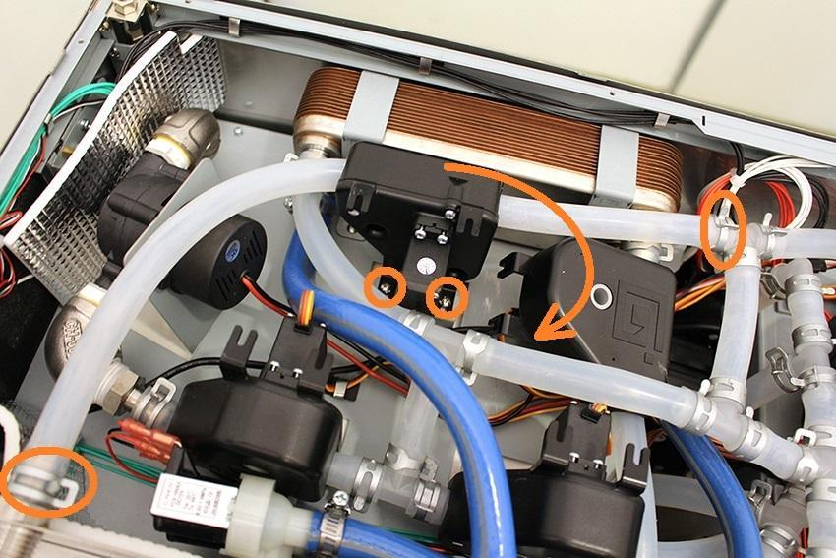

Unscrew the indicated screws and remove the heat exchanger holder clamps.

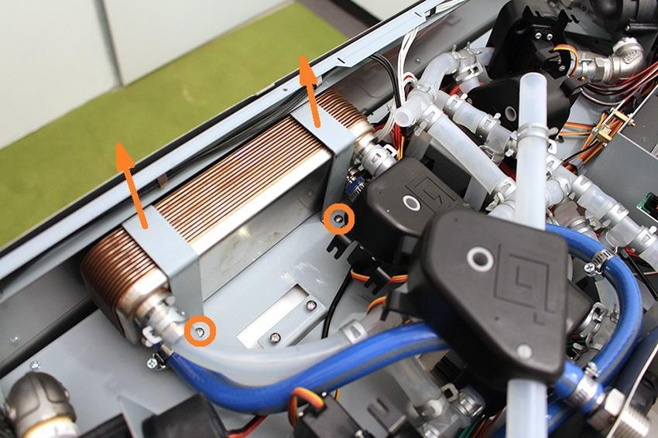

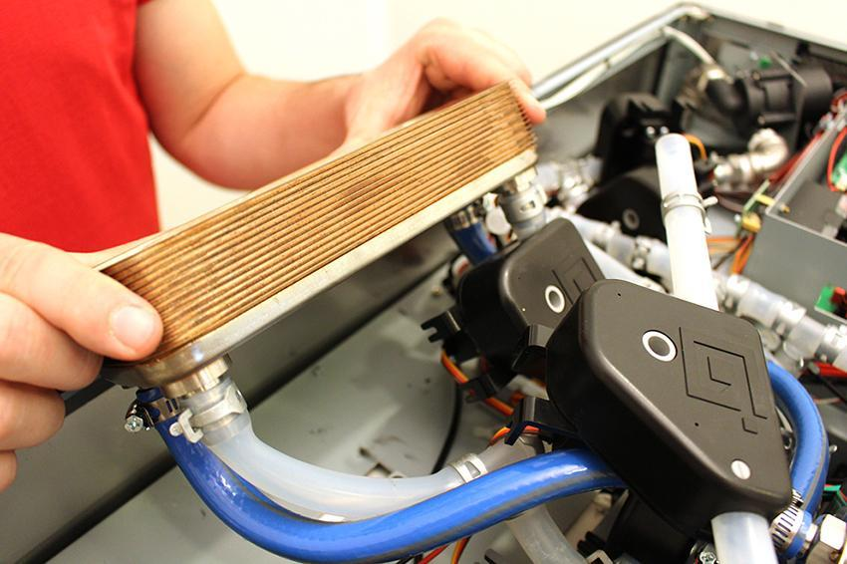

Remove the hose clamps and hoses from the heat exchanger.

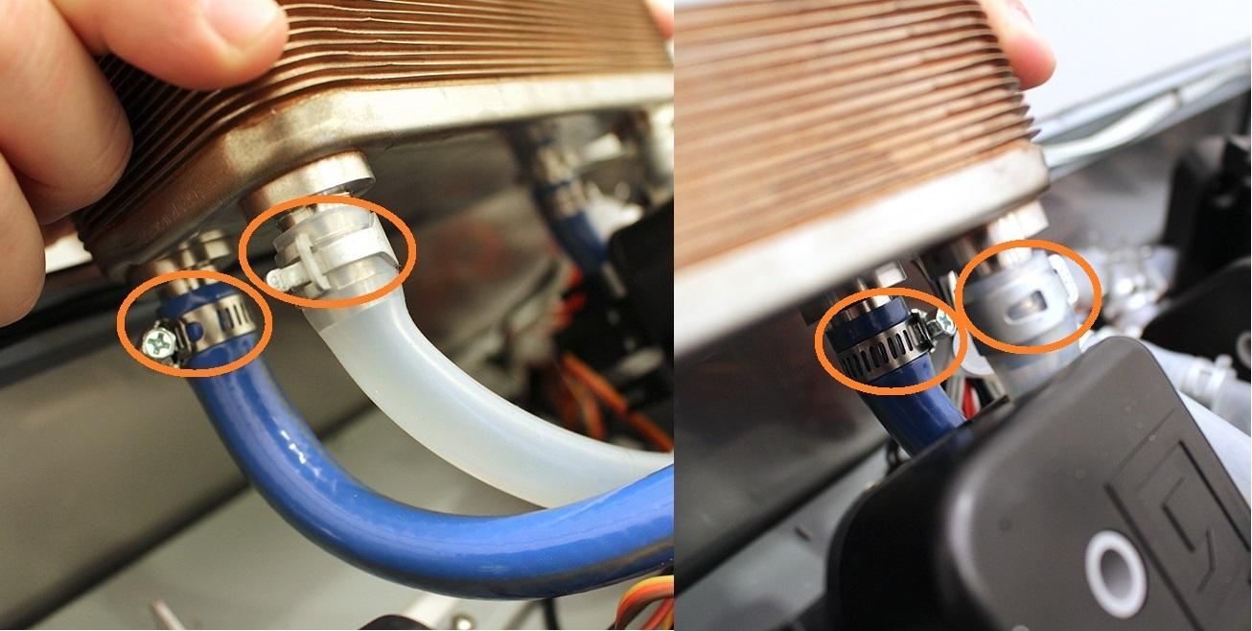

Now you can replace the heat exchanger.

Reassemble consists of the same steps in reverse.

Make sure that the wort outlet hose clamp is in the proper angle. Otherwise you cannot reassemble the bottom sheetmetal.

